YOLO training:
https://learnopencv.com/train-yolov8-on-custom-dataset/

Video Labeling:
https://docs.aws.amazon.com/sagemaker/latest/dg/sms-video-overview.html
https://docs.aws.amazon.com/sagemaker/latest/APIReference/API_CreateLabelingJob.html
https://aws.amazon.com/blogs/machine-learning/streamlining-data-labeling-for-yolo-object-detection-in-amazon-sagemaker-ground-truth/
https://aws.amazon.com/blogs/machine-learning/streamlining-data-labeling-for-yolo-object-detection-in-amazon-sagemaker-ground-truth/

https://aws.amazon.com/blogs/machine-learning/streamlining-data-labeling-for-yolo-object-detection-in-amazon-sagemaker-ground-truth/
https://www.youtube.com/watch?v=beknlA2BHGo
https://www.youtube.com/watch?v=UZBL4jgTpOs&t=1s
https://www.youtube.com/watch?v=PpjlM-EdVrc

Error: ModelError: InvokeEndpoint operation: Received server error (500)
https://repost.aws/questions/QULAis68RtShua1Wg8A5EFXg/deploy-yolov5-in-sagemaker-modelerror-invokeendpoint-operation-received-server-error-0

YOLO model training :

https://github.com/shantamsultania/object_detection_using_yolo_in_video_and_webcam/blob/master/Real%20time%20object%20detection.py

Suggestion from Lovish :
- https://github.com/aws-samples/deploy-yolov8-on-edge-using-aws-iot-greengrass/blob/main/README.md

NVIDA ON AWS VM

- TAO limitation with NIVIDIA: Amazon Sagemaker - Intelligent Video Analytics / TAO Toolkit - NVIDIA Developer Forums
- NVIDIA TAO on AWS VM setup : Running TAO on an AWS VM - NVIDIA Docs
- NVIDIA NGC ON AWS VM : NGC on AWS Virtual Machines - NVIDIA Docs
- TAO TOOlKIt setup : Overview - NVIDIA Docs
- NGC ON AWS EC2 VM : https://ngc.nvidia.com/docs/aws , https://docs.nvidia.com/ngc/deploy-public-cloud/ngc-aws/index.html
- https://ngc.nvidia.com/docs/aws
- NGC on AWS Virtual Machines: https://docs.nvidia.com/ngc/ngc-deploy-public-cloud/ngc-aws/index.html#launching-vm-instance-from-console
- TAO tutorial : tao_tutorials/notebooks/tao_api_starter_kit/api/object_detection.ipynb at main · NVIDIA/tao_tutorials · GitHub
- TAO beginner toolkit setup : Beginners - NVIDIA Docs
- AWS quick guide: https://docs.nvidia.com/search/index.html?facet.docs_product[]=NVIDIA%20TAO&facet.mimetype[]=webpage&facet.subcollection[]=Technical%20Documentation&page=1&sort=relevance&term=AWS%20
- Getting Started with NVIDIA Enterprise on AWS Enterprise: https://www.youtube.com/watch?v=EL8AsG0R0Bg
- EXTRA: AWS re:Invent 2022 - Deep learning on AWS with NVIDIA: From training to deployment (PRT219) : https://www.youtube.com/watch?v=l8AFfaCkp0E&t=865s
- Running TAO on an AWS VM: https://docs.nvidia.com/tao/tao-toolkit/text/running_in_cloud/running_tao_toolkit_on_aws.html
- TAO Toolkit AWS SM Deployment: https://forums.developer.nvidia.com/t/tao-toolkit-aws-sagemaker-deployment/274670 , https://forums.developer.nvidia.com/t/nvidia-tao-deploy-pycocotools-fix-issue-python-wheels-tao-implementation-porting-from-collab-to-aws-sagemaker-studio/274139
- TAO Quick start: https://docs.nvidia.com/tao/tao-toolkit-archive/tao-30-2205/text/tao_toolkit_quick_start_guide.html
- DOCKER

- How to use NVIDIA : https://www.youtube.com/watch?v=Ufd86duobvc

Dsakk
DOCKER :
- https://docs.docker.com/engine/install/linux-postinstall/
- https://docs.docker.com/compose/install/linux/
- https://docs.docker.com/compose/install/linux/#install-using-the-repository
- https://docs.docker.com/compose/install/linux/#install-the-plugin-manually
- https://docs.docker.com/engine/install/ubuntu/

Nextr

AWS ECR registry : Amazon ECR private registry - Amazon ECR
AWS NVIDIA drivers for your Amazon EC2 : https://docs.aws.amazon.com/AWSEC2/latest/UserGuide/install-nvidia-driver.html

AWS Build machine learning at the edge applications using Amazon SageMaker Edge Manager and AWS IoT Greengrass V2
- Build machine learning at the edge applications using Amazon SageMaker Edge Manager and AWS IoT Greengrass V2 | AWS Machine Learning Blog
- Using AWS IoT Greengrass Version 2 with Amazon SageMaker Neo and NVIDIA DeepStream Applications | The Internet of Things on AWS – Official Blog
- IOT on AWS: How MTData built a CVML vehicle telematics and driver monitoring solution with AWS IoT | The Internet of Things on AWS – Official Blog (amazon.com)
- ML inferencing at the edge with Amazon SageMaker Edge and Ambarella CV25 | AWS Machine Learning Blog

14 Sep 2024 : SAGEMAKER OBJECT DETECTION MODEL (without NVIDIA model)

SAGE MAKER object detection model:
- git repo for SM obj det model : https://github.com/aws/amazon-sagemaker-examples/blob/main/introduction_to_amazon_algorithms/object_detection_tensorflow/Amazon_Tensorflow_Object_Detection.ipynb
- Youtube sM studio dev env for ML : https://www.youtube.com/watch?v=7QSsysGX14w
- NGC pretrained Obj Dect Model: https://catalog.ngc.nvidia.com/orgs/nvidia/teams/tao/models/pretrained_object_detection
- Sagemaker Neo (model performance using Neo): Optimize model performance using Neo - Amazon SageMaker
- 5. IOT analytics on AWS: Unlocking Scalable IoT Analytics on AWS | The Internet of Things on AWS – Official Blog (amazon.com)
- amazon-sagemaker-examples/introduction_to_amazon_algorithms/object_detection_birds/object_detection_birds.ipynb at 653a1f4dab2d0347fdef6202ab755bef10ac2f30 · aws/amazon-sagemaker-examples · GitHub
- GitHub - aws/amazon-sagemaker-examples: Example 📓 Jupyter notebooks that demonstrate how to build, train, and deploy machine learning models using 🧠 Amazon SageMaker.
- ML inferencing at the edge with Amazon SageMaker Edge and Ambarella CV25 | AWS Machine Learning Blog
- Docker engine in Sagemaker Studio is not supported: https://stackoverflow.com/questions/76250060/is-it-possible-to-use-docker-commands-in-sagemaker-studio , https://github.com/aws-samples/sagemaker-studio-image-build-cli
- Install new python version on SM: https://www.youtube.com/watch?v=oVUA1yUtme0, https://docs.aws.amazon.com/sagemaker/latest/dg/nbi-add-external.html

next
SageMaker Neo

- Optimize model performance using NEO: https://docs.aws.amazon.com/sagemaker/latest/dg/neo.html
- Getting started on NEO: https://docs.aws.amazon.com/sagemaker/latest/dg/neo-getting-started-edge.html
- Compile mode using NEO: https://docs.aws.amazon.com/sagemaker/latest/dg/neo-job-compilation.html
- Getting started on Edge device : https://docs.aws.amazon.com/sagemaker/latest/dg/neo-getting-started-edge.html
- Sagemaker edge manager end of life cycle: https://docs.aws.amazon.com/sagemaker/latest/dg/edge-eol.html
- https://aws.amazon.com/blogs/machine-learning/category/artificial-intelligence/sagemaker/amazon-sagemaker-neo/
- Amz SM on Edge: https://aws.amazon.com/sagemaker/edge/

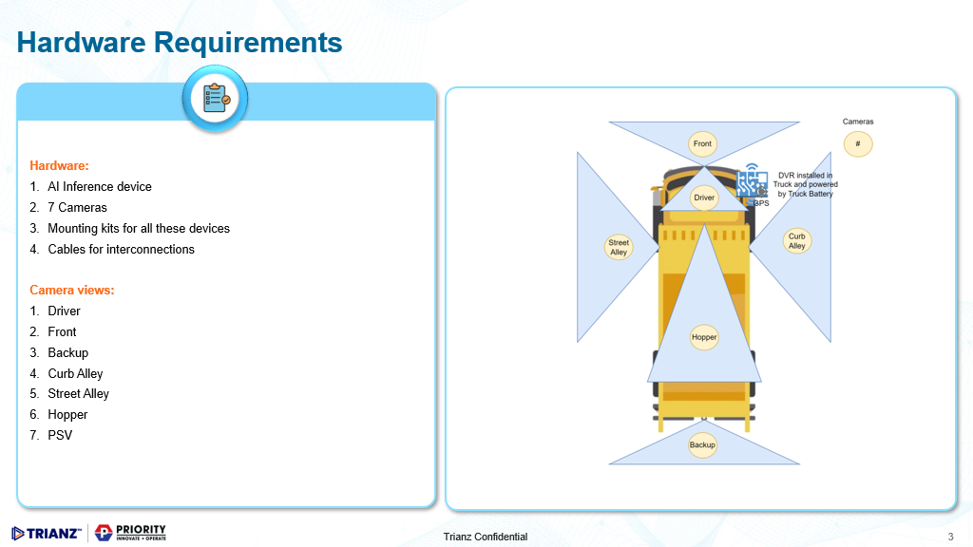

- AWS Sagemaker IOT certification to register as a thing Amazon Kinesis we can use live video
- Use WebRTC to ge

S.No | Services
1 | AWS sage maker
2 | GPU,
3 | s3 bucket,
4 | amazon Kinesis
5 | Aws IOT core
6 | AWS IOT Greengrass
7 | AWS IoT Fleetwise
8 | AWS Quicksight
9 | AppSync
10 | AWS SageMaker Neo

https://docs.aws.amazon.com/kinesisvideostreams-webrtc-dg/latest/devguide/what-is-kvswebrtc.html
https://www.youtube.com/watch?v=8GZDmdBwVqU

https://docs.nvidia.com/tao/tao-toolkit-archive/tao-30-2205/text/tao_toolkit_quick_start_guide.html

https://www.youtube.com/watch?v=oVUA1yUtme0 – create conda with specific py

python -m ipykernel install --user --name py_3716_env --display-name 'py_3_7_16'
Installed kernelspec py_3716_env in /home/sagemaker-user/.local/share/jupyter/kernels/py_3716_env

git clone https://github.com/NVIDIA/tao_tutorials.github

Docker – vc code(di) github sagemaker

IOT GREEN GRASS:
https://aws.amazon.com/greengrass/ml/

aws configure sso

create folder in s3:

Thirumoorthy, Nirmalrajhen
6:23 PM
aws sts get-caller-identity
Thirumoorthy, Nirmalrajhen's message action menu
echo $AWS_SECRET_ACCESS_KEY
Thirumoorthy, Nirmalrajhen's message action menu
echo $AWS_ACCESS_KEY_ID
Thirumoorthy, Nirmalrajhen's message action menu
aws configure list
Thirumoorthy, Nirmalrajhen's message action menu

Manage access keys for IAM users - AWS Identity and Access Management
docs.aws.amazon.com
https://docs.aws.amazon.com/IAM/latest/UserGuide/id_credentials_access-keys.html
Thirumoorthy, Nirmalrajhen's message action menu

Configure the AWS CLI with IAM Identity Center authentication - AWS Command Line Interface
docs.aws.amazon.com
https://docs.aws.amazon.com/cli/latest/userguide/cli-configure-sso.html
Thirumoorthy, Nirmalrajhen's message action menu

Creating a directory bucket - Amazon Simple Storage Service
docs.aws.amazon.com
https://docs.aws.amazon.com/AmazonS3/latest/userguide/directory-bucket-create.html
Thirumoorthy, Nirmalrajhen's message action menu
aws s3api create-bucket \ --bucket my-bucket \ --region us-east-1

aws configure sso
my_test_session
:sso:account:access
SSO start URL [None]: https://prioritywaste.awsapps.com/start/#
SSO region [None]: us-east-1
SSO registration scopes [sso:account:access]: sso:account:access
Attempting to automatically open the SSO authorization page in your default browser.
If the browser does not open or you wish to use a different device to authorize this request, open the following URL:

https://device.sso.us-east-1.amazonaws.com/

Then enter the code:

LJGQ-SPCQ
There are 2 AWS accounts available to you.
Using the account ID 730335309831
There are 2 roles available to you.
Using the role name "IoTFleet-Team"
CLI default client Region [us-east-1]: us-east-1
CLI default output format [json]: json
CLI profile name [IoTFleet-Team-730335309831]: Pallavi
C:\Users\pallavi.priya >aws s3 ls --profile Pallavi
To create a new bucket in s3:

C:\Users\pallavi.priya>aws s3api create-bucket --bucket dataset --region us-east-1 --profile Pallavi

arn:aws:s3:::fleet-dataset

As per our findings, we will be needing minimum requirement as mentioned below:
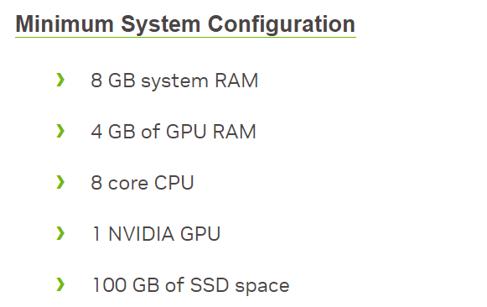
According to minimum requirement either we can choose once of the options mentioned below:
- 2 * (ml.g4dn.xlarge with 50 GB ) memory [Recommendation]
- ml.g4dn.xlarge with 100 GB resource
Below are the reason we have recommended option 1 :
- YOLO models, especially during training, require significant GPU memory. Training two YOLO models at the same time will put a heavy load on the 16 GB T4 GPU. Depending on the batch size, image resolution, and model complexity, you may encounter out-of-memory (OOM) errors.
- With only 16 GB of system RAM, running two models with separate configurations may stretch the available memory. While disk swap can help, it will significantly slow down performance.
- Running two models simultaneously on 1 GPU could lead to resource contention, where both models will compete for the GPU’s processing power. This can severely degrade performance, increasing training time and potentially causing bottlenecks in the data pipeline.
For parallel training of two models, using two separate ml.g4dn.xlarge instances is the most efficient approach.
If you're willing to train sequentially or reduce resource usage, you could attempt to train both on the same instance, but this will likely increase training time and complicate the process.

arn:aws:s3:::fleet-dataset

NVIDIA :

Leung, Christopher
7:00 PM

Setup - NVIDIA Docs
docs.nvidia.com
https://docs.nvidia.com/tao/tao-toolkit/text/tao_toolkit_api/api_setup.html#aws-eks-setup
Leung, Christopher's message action menu

NVIDIA-TAO-Deploy -pycocotools-fix issue - Python Wheels TAO implementation porting from Collab to AWS SageMaker Studio - #8 by riyang1 - TAO Toolkit - NVIDIA Developer Forums
forums.developer.nvidia.com
https://forums.developer.nvidia.com/t/nvidia-tao-deploy-pycocotools-fix-issue-python-wheels-tao-implementation-porting-from-collab-to-aws-sagemaker-studio/274139/8
Leung, Christopher's message action menu

Local mode support in Amazon SageMaker Studio - Amazon SageMaker
docs.aws.amazon.com
https://docs.aws.amazon.com/sagemaker/latest/dg/studio-updated-local.html
Leung, Christopher's message action menu
‹Pallavi Priya›
7:05 PM

Running TAO on an AWS VM - NVIDIA Docs
docs.nvidia.com
https://docs.nvidia.com/tao/tao-toolkit/text/running_in_cloud/running_tao_toolkit_on_aws.html
‹Pallavi Priya›'s message action menu
Leung, Christopher
7:06 PM
https://docs.aws.amazon.com/ec2/
Leung, Christopher's message action menu

Dockerfile628 Bytes

Leung, Christopher's message action menu

Amazon ECR private registry - Amazon ECR
docs.aws.amazon.com
https://docs.aws.amazon.com/AmazonECR/latest/userguide/Registries.html
Leung, Christopher's message action menu

Amazon Sagemaker - TAO Toolkit - NVIDIA Developer Forums
forums.developer.nvidia.com
https://forums.developer.nvidia.com/t/amazon-sagemaker/265642

communication with AWS support – for EC2 VM
NGC on AWS Virtual Machines - NVIDIA Docs
docs.nvidia.com
https://docs.nvidia.com/ngc/ngc-deploy-public-cloud/ngc-aws/index.html

NVIDIA NGC
ngc.nvidia.com
https://ngc.nvidia.com/docs/aws
NGC on AWS Virtual Machines - NVIDIA Docs
docs.nvidia.com
https://docs.nvidia.com/ngc/ngc-deploy-public-cloud/ngc-aws/index.html#selecting-nv-volta-deeplearning-ami
"NVIDIA Volta Deep Learning AMI"
amazon-sagemaker-examples/introduction_to_amazon_algorithms/jumpstart_object_detection/Amazon_JumpStart_Object_Detection.ipynb at main · aws/amazon-sagemaker-examples · GitHub

justification:
While working on ML model for PW POC, there were some blockers and limitations we faced due to which we have decided to move some tasks to sprint2 like:
- Access level issue on AWS instance.
- Depending on it team for application installation. (Annotator tool for preparing dataset)
- While working with Model we found certain limitations from Sagemaker to build NVIDIA model, due to while we have decided to try different approaches to meet the end goal. Hence we have moved our pending tasks to sprint 2 and made sub modules to follow the different approaches.

CHALLENGES:
- Dataset challenge
- Annotation tool section
- Model selection – YOLO(pyTorch), tflife, ONX,
- Not classification , making object tracking
- IOT green grass

